**Project Data Flow Diagram**

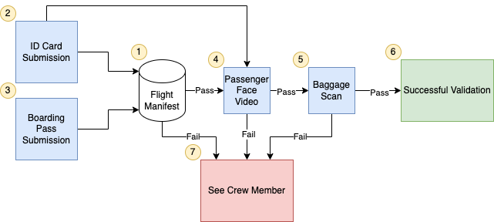

**Legend**

**Blue –** User or kiosk input

**Red –** Failure result

**Green –** Successful result

**Data Flow**

1. A manifest is created with the information for every member boarding the flight.
2. The member submits their ID card, this information is validated with the manifest.
3. The member submits their boarding pass, this information is validated with the manifest.
4. The kiosk scans the member’s face and validates with the image on the ID card.
5. The kiosk scans the member’s luggage and validates there is not a lighter present.
6. If the member has passed all validations, a successful validation message is passed and they are permitted to board the airplane.
7. If the member fails any validation step the member is directed to see a crew member for manual validation and check-in.